Innovaciencia 202#; # (#): xxx-xxx
Title of the scientific research paper in English.
(Garamond 18 pt, Capitalize only the first letter in the title)

Name and last name *, Name and last name , Name and last name , etc.
(Name and last name in Garamond 12 pt – 1.5 line spacing)
Received xxxxx xxxx and accepted for publicationxx xxxx xxxx

How to cite this article: Last name N., Last name N., Last name N. Title of the scientific research article, Innovaciencia 202#; # (#): xxx-xxx
(Last Name and First Initials, Garamond 12 pt, 1.5 Line Spacing, Justified Text)

Highlights: (Authors should provide two or three self-authored sentences representing relevant aspects of the publication, each between 15 and 30 words.

- Xxx xxxx xxxxxx xx xxxxxx xxxxxx xxxxxxxxx xxxx xxxxxx
- Xxxx xxxx xxxxx xxxxxx xxxxxx xxxxxx xxxxxx xxx xxxxxxx
- Xxxxxxx xxxxxxxxx xxxxxxxxxx xxx xxxxxx xxxx xxxx xxxx

ABSTRACT
It should be organized according to the structure indicated in the author's guidelines, (Garamond 12 pt font, 1.5 line spacing). Introduction: xxxxxxxxx xxxxxxxxxxxxxx xxxxxxxxxxxx xxxxxxxxxxx xxxxxxxxxxxxxx xxxxxxxxxxxxxx xxxxxxxxxxx xxxxxxxxxx xxxxxxxxxxx xxxxxxxxxxxx xxxxxxxxxx xxxxxxxxxxx xxxxxxxxxxxxxx Objetives: xxxxxxxxxxxxx xxxxxxxxxx xxxxxxxx xxxxxxxx xxxxxxxxxx xxxxxx xxxxxxxxx xxxxxxxxxx xxxxxxx xxxxxx. Materials and Methods: xxxxxxxxx xxxxxxxxxxxxxx xxxxxxxxxxxx xxxxxxxxxxx xxxxxxxxxxxxxx xxxxxxxxxxxxxx xxxxxxxxxxx xxxxxxxxxx xxxxxxxxxxx xxxxxxxxxxxx xxxxxxxxxx xxxxxxxxxxx xxxxxxxxxxxx xxxxxxxxxxx xxxxxxxxxxx xxxxxxxxxx xxxxxxxxxx xxxxxxxxxxxxx xxxxxxxxxxxxxx xxxxxxxxxxxxxx xxxxxxxxxxxx. Results and Discussion: xxxxxxxxx xxxxxxxxxxxxxx xxxxxxxxxxxx xxxxxxxxxxx x xxxxxxxx xxxx xxxxxxxxxxx xxxxxxxxxx xxxxxxxxxxxx xxxxxxxxxxxxxxxx xxxxxxxxxxxx xxxxxxxxxxx xxxxxxxxxxx xxxxxxxxxx xxxxxxxxxx xxxxxxxxxxxxx xxxxxxxxxxxxxx xxxxxxxxxxxxxx xxxxxxxxxxxx. Conclusions: xxxxxxxxx
Key words 1st Word;2nd Word; 3rd Word; etc., (Terms composed of one or more words to identify main research topics)

INTRODUCTION
This section serves to introduce the reader to the topic of the article. It provides a summary of the theoretical advancements and research that support the work presented in the article. This section highlights the significance of the research and concludes with the objective(s) of the article. Please cite the sources used in the creation of this section (Use: Garamond 12 pt font, 1.5 line spacing).
xxxxxxxxxxxxxx xxxxxxxxxxx xxxxxxxxxx xxxxxxxxxxx xxxxxxxxxxxx xxxxxxxxxx xxxxxxxxxxx xxxxxxxxxx xxxxxxxxxxxx xxxxxxxxxxxxxxxx xxxxxxxxxxxx xxxxxxxxxxx xxxxxxxxxxx xxxxxxxxxx xxxxxxxxxx xxxxxxxxxxxxx xxxxxxxxxxxxxx xxxxxxxxxxxxxx xxxxxxxxxxx xxxxxxxxxx xxxxxxxxxxx xxxxxxxxxxxx xxxxxxxxxx xxxxxxxxxxx xxxxxxxxxx xxxxxxxxxxxx xxxxxxxxxxxxxxxx xxxxxxxxxxxx xxxxxxxxxxx xxxxxxxxxxx xxxxxxxxxx xxxxxxxxxx xxxxxxxxxxxxx xxxxxxxxxxxxxx xxxxxxxxxxxxxx xxxxxxxxxxxx. xxxxxxxxxxxxxx xxxxxxxxxxxx xxxxxxxxxxx xxxxxxxxxxxxxx xxxxxxxxxxxxxx xxxxxxxxxxx xxxxxxxxxx xxxxxxxxxxx xxxxxxxxxxxx xxxxxxxxxx xxxxxxxxxxx xxxxxxxxxx xxxxxxxxxxxx

MATERIALS AND METHODS
The study type, its design, the population characteristics, and the groups formed. Additionally, it should detail all the techniques and elements used during the study. The methods and/or strategies to arrive at the results and their interpretation are also described (Statistical Analysis: If you use any software, mention it, specify the version, and include the respective reference). Finally, in research involving humans and/or animals, an item of ethical considerations must be included specifying the standards it complies with, the name of the Ethics Committee that approved the study, the registration number or minutes assigned by the Committee. If applicable to the study, mention permits for the collection of microorganisms, plants, and animals (Use: Garamond 12 pt font, 1.5 line spacing) xxxxxxxxx xxxxxxxxxxxxxx xxxxxxxxxxxx xxxxxxxxxxx xxxxxxxxxxxxxx xxxxxxxxxxxxxx xxxxxxxxxxx xxxxxxxxxx xxxxxxxxxxx xxxxxxxxxxxx xxxxxxxxxx xxxxxxxxxxx xxxxxxxxxx xxxxxxxxxxxx xxxxxxxxxxxxxxxx xxxxxxxxxxxx xxxxxxxxxxx xxxxxxxxxxx xxxxxxxxxx xxxxxxxxxx xxxxxxxxxxxxx xxxxxxxxxxxxxx xxxxxxxxxxxxxx xxxxxxxxxxxx. xxxxxxxxxxxxxx xxxxxxxxxxxx xxxxxxxxxxx xxxxxxxxxxxxxx xxxxxxxxxxxxxx xxxxxxxxxxx xxxxxxxxxx xxxxxxxxxxx xxxxxxxxxxxx xxxxxxxxxx xxxxxxxxxxx xxxxxxxxxx xxxxxxxxxxxx xxxxxxxxxxxxxxxx xxxxxxxxxxxx xxxxxxxxxxx xxxxxxxxxxx xxxxxxxxxx xxxxxxxxxx
RESULTS
The results obtained by applying the methods described in the previous item must be presented in a logical and chronological manner, for this you can use tables, figures and/or graphs (Use: Garamond 12pt, line spacing 1.5). Please do not repeat all the data from the tables or figures in the text, highlight or summarize only the most relevant observations. xxxxxxxxx xxxxxxxxxxxxxx xxxxxxxxxxxx xxxxxxxxxxx xxxxxxxxxxxxxx xxxxxxxxxxxxxx xxxxxxxxxxx xxxxxxxxxx xxxxxxxxxxx xxxxxxxxxxxx xxxxxxxxxx xxxxxxxxxxx xxxxxxxxxx xxxxxxxxxxxx xxxxxxxxxxxxxxxx xxxxxxxxxxxx xxxxxxxxxxx xxxxxxxxxxx xxxxxxxxxx xxxxxxxxxx xxxxxxxxxxxxx xxxxxxxxxxxxxx xxxxxxxxxxxxxx xxxxxxxxxxxx. xxxxxxxxxxxxxx xxxxxxxxxxxx xxxxxxxxxxx xxxxxxxxxxxxxx xxxxxxxxxxxxxx xxxxxxxxxxx xxxxxxxxxx xxxxxxxxxxx xxxxxxxxxxxx xxxxxxxxxx xxxxxxxxxxx xxxxxxxxxx xxxxxxxxxxxx xxxxxxxxxxxxxxxx xxxxxxxxxxxx xxxxxxxxxxx

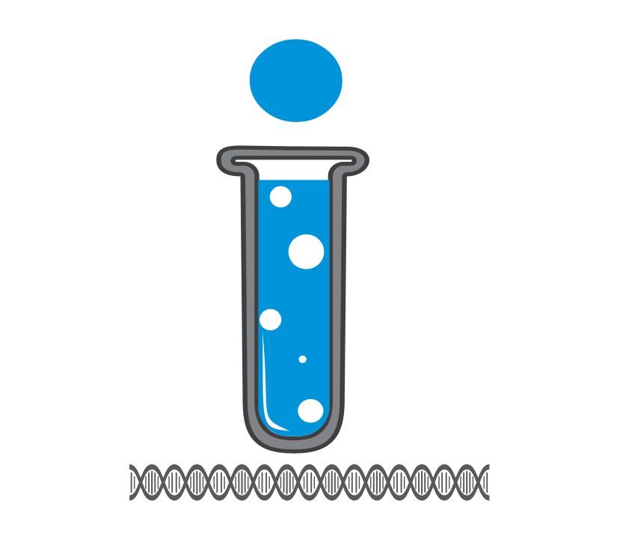
Figure 1. Figure description (caption)
The figures must be numbered sequentially, have a legend, and be included in the manuscript. All necessary explanations (abbreviations or symbols) should appear in the footnotes of the figure. Additionally, you must upload the images in a separate file that allows their subsequent layout, for the type of format and resolution, please consult the guidelines for author. If the figures are not of your authorship, without exception, you must send INNOVACIENCIA the authorization signed by the publishing house or person who holds the copyright where you grant the publication permission.
Figure example: https://revistas.udes.edu.co/innovaciencia/article/view/2563/2346075X.2563

Table 1. Table description (caption)

xxxxxxx | xxxxxxx | XXXX |  |  | XXXX
 |  | XXXXX | XXXXX | XXXXX | XXXXX | XXXX | XXXXX
Note: All the necessary explanations should appear for clarity to the reader (abbreviations, symbols, statistical test used for the calculation of the p-value, etc.,).
Tables should be numbered sequentially as follows (Table 1, Table 2, etc.), have a legend, and be included in the manuscript in editable or compatible Word format. In percentage data, for decimals (present two decimal places and the "n" in parentheses, e.g., 10.27% (14)). When references are cited in tables, they should follow the order in which they were used in the text.
Table example: https://revistas.udes.edu.co/innovaciencia/article/view/2563/2346075X.2563

In case your manuscript has original data in extensive tables with relevant information that cannot be incorporated as a Word file, submit them as a supplementary file in Excel format. These files must be properly numbered and have an associated legend in the text. Table´s ID should appear as follows: Table S1, Table S2, etc. If the tables are not of your authorship without exception, you must send to INNOVACIENCIA the authorization signed by the publishing house or person who holds the copyright where you grant the publication permission.

DISCUSSION
This section should provide an interpretation of the previously described results. Emphasize new and important aspects of your findings and compare them with other relevant studies. This section serves as a platform to reflect on the new knowledge generated, its connection to existing knowledge, and potential implications.
Where appropriate, discuss the influence or association of variables and acknowledge any limitations of the data. Avoid simply repeating information presented elsewhere in the manuscript, such as the Introduction or Results sections. (f Garamond 12pt, line spacing 1.5) xxxxxxxxx xxxxxxxxxxxxxx xxxxxxxxxxxx xxxxxxxxxxx xxxxxxxxxxxxxx xxxxxxxxxxxxxx xxxxxxxxxxx xxxxxxxxxx xxxxxxxxxxx xxxxxxxxxxxx xxxxxxxxxx xxxxxxxxxxx xxxxxxxxxx xxxxxxxxxxxx xxxxxxxxxxxxxxxx xxxxxxxxxxxx xxxxxxxxxxx xxxxxxxxxxx xxxxxxxxxx xxxxxxxxxx xxxxxxxxxxxxx xxxxxxxxxxxxxx xxxxxxxxxxxxxx xxxxxxxxxxxx. xxxxxxxxxxxxxx xxxxxxxxxxxx xxxxxxxxxxx xxxxxxxxxxxxxx xxxxxxxxxxxxxx xxxxxxxxxxx xxxxxxxxxx xxxxxxxxxxx xxxxxxxxxxxx xxxxxxxxxx xxxxxxxxxxx xxxxxxxxxx xxxxxxxxxxxx xxxxxxxxxxxxxxxx xxxxxxxxxxxx xxxxxxxxxxx xxxxxxxxxxx xxxxxxxxxx xxxxxxxxxx xxxxxxxxxxxxx xxxxxxxxxxxxxx xxxxxxxxxxxxxx xxxxxxxxxxxx. xxxxxxxxxxxxxx xxxxxxxxxxxx xxxxxxxxxxx xxxxxxxxxxxxxx xxxxxxxxxxxxxx xxxxxxxxxxx xxxxxxxxxx xxxxxxxxxxx xxxxxxxxxxxx xxxxxxxxxx

CONCLUSIONS
This section expresses the opinions and concepts, based on the results, that they arrive at after the discussion. Declare new hypotheses when justified but make it clear that they are hypotheses (Garamond 12pt, line spacing 1.5) xxxxxxxxx xxxxxxxxxxxxxx xxxxxxxxxxxx xxxxxxxxxxx xxxxxxxxxxxxxx xxxxxxxxxxxxxx xxxxxxxxxxx xxxxxxxxxx xxxxxxxxxxx xxxxxxxxxxxx xxxxxxxxxx xxxxxxxxxxx xxxxxxxxxx xxxxxxxxxxxx xxxxxxxxxxxxxxxx xxxxxxxxxxxx xxxxxxxxxxx xxxxxxxxxxx xxxxxxxxxx xxxxxxxxxx xxxxxxxxxxxxx xxxxxxxxxxxxxx xxxxxxxxxxxxxx xxxxxxxxxxxx. xxxxxxxxxxxxxx xxxxxxxxxxxx xxxxxxxxxxx xxxxxxxxxxxxxx xxxxxxxxxxxxxx xxxxxxxxxxx xxxxxxxxxx xxxxxxxxxxx xxxxxxxxxxxx xxxxxxxxxx xxxxxxxxxxx xxxxxxxxxx xxxxxxxxxxxx xxxxxxxxxxxxxxxx xxxxxxxxxxxx xxxxxxxxxxx xxxxxxxxxxx xxxxxxxxxx xxxxxxxxxx xxxxxxxxxxxxx xxxxxxxxxxxxxx xxxxxxxxxxxxxx xxxxxxxxxxxx. xxxxxxxxxxxxxx xxxxxxxxxxxx xxxxxxxxxxx xxxxxxxxxxxxxx xxxxxxxxxxxxxx xxxxxxxxxxx xxxxxxxxxx xxxxxxxxxxx xxxxxxxxxxxx xxxxxxxxxx xxxxxxxxxxx xxxxxxxxxx xxxxxxxxxxxx xxxxxxxxxxxxxxxx xxxxxxxxxxxx xxxxxxxxxxx xxxxxxxxxxx xxxxxxxxxx xxxxxxxxxx.

ACKNOWLEDGMENTS
xxxxxxxxx xxxx xxxxxxxxxxx xxxxxx xxxxxxxxxxxxxxxxx xxxxxxxx xxxxxxx

FUNDING
xxxxxxx xxxxxx xxx

REFERENCES
Please review this section carefully and follow the instructions given for authors to construct references. Consider these general recommendations:

- Please ensure that your references are formatted in Vancouver style and have active hyperlinks.
- Preferably, reference published and formally accepted articles (in press).
- Citations within the main text are made by means of consecutive Arabic numerals, in parentheses and with superscript, e.g. without mentioning author: xxxx⁽¹⁾, in case you need to mention the authors, you can use the following examples within the text: for an author: Sandoval-Ramírez⁽¹⁾; for two authors: García-Suárez and Novoa-Álvarez⁽¹⁾; for more than two authors: González-Marín et al.,⁽¹⁾.
- Each reference indicated throughout the main text or in the tables should be referenced in this section.
- Author surname(s) and initial(s) in bold.
- Abbreviate journal titles according to the List of Title Word Abbreviations: Access to the LTWA | ISSN (https://www.issn.org/services/online-services/access-to-the-ltwa/#lettres
- The data of the year of publication, volume, number, and pages should be written continuously, without spaces between them (e.g. 2016;7(2):1338-44).
- When available, include the stable doi URL at the end of the reference or the doi.

Annexes: Required Files for Submission
When submitting your article, please ensure you upload the following files:
- Manuscript. (Original version with authors' data)
- Manuscript. (Anonymous version: no author´s data).
- Form 1. Originality, Authorship, and Conflict of Interest
- Form 2. Ethical Principles

- Form 3. Cover letter. Follow the author's guidelines for writing its content.

- Figures In original format that allows layout. Follow the author's guidelines to review the features requested by Innovaciencia.
- Supplementary Figures. (Just if it´s requiered), Follow the author's guidelines to review the features required by Innovaciencia
- Supplementary Tables. (Just if it´s requiered), Follow the author's guidelines for its construction and review the features required by Innovaciencia.

Institutional Affiliation, e-mail, ORCID
Institutional Affiliation, e-mail, ORCID
Institutional Affiliation, e-mail, ORCID * Corresponding Author

