Innovaciencia 202#; #(#): xxx-xxx

Title of the short communication in English.
(Garamond 12 pt, Capitalize only the first letter in the title)

Name and last name *, Name and last name , Name and last name , etc.
(Name and last name in Garamond 12 pt – 1.5 line spacing)
How to cite this article: Last name N., Last name N., Last name N. Title of the scientific research article, Innovaciencia 202#; # (#): xxx-xxx
(Last Name and First Initials, Garamond 12 pt, 1.5 Line Spacing, Justified Text)

Highlights: (Authors should provide two or three self-authored sentences representing relevant aspects of the publication, each between 15 and 30 words.

- Xxx xxxx xxxxxx xx xxxxxx xxxxxx xxxxxxxxx xxxx xxxxxx
- Xxxx xxxx xxxxx xxxxxx xxxxxx xxxxxx xxxxxx xxx xxxxxxx
- Xxxxxxx xxxxxxxxx xxxxxxxxxx xxx xxxxxx xxxx xxxx xxxx

ABSTRACT
It should be organized according to the structure indicated in the author's guidelines (Garamond 12 pt font, 1.5 line spacing). Introduction. xxxxxxxxx xxxxxxxxxxxxxx xxxxxxxxxxxx xxxxxxxxxxx xxxxxxxxxxxxxx xxxxxxxxxxxxxx xxxxxxxxxxx xxxxxxxxxx xxxxxxxxxxx xxxxxxxxxxxx xxxxxxxxxx xxxxxxxxxxx xxxxxxxxxxxxxx Objetives. xxxxxxxxxxxxx xxxxxxxxxx xxxxxxxx xxxxxxxx xxxxxxxxxx xxxxxx xxxxxxxxx xxxxxxxxxx xxxxxxx xxxxxx. Materials and Methods. xxxxxxxxx xxxxxxxxxxxxxx xxxxxxxxxxxx xxxxxxxxxxx xxxxxxxxxxxxxx xxxxxxxxxxxxxx xxxxxxxxxxx xxxxxxxxxx xxxxxxxxxxx xxxxxxxxxxxx xxxxxxxxxx xxxxxxxxxxx xxxxxxxxxxxx xxxxxxxxxxx xxxxxxxxxxx xxxxxxxxxx xxxxxxxxxx xxxxxxxxxxxxx xxxxxxxxxxxxxx xxxxxxxxxxxxxx xxxxxxxxxxxx. Results. xxxxxxxxx xxxxxxxxxxxxxx xxxxxxxxxxxx xxxxxxxxxxx x xxxxxxxx xxxx xxxxxxxxxxx xxxxxxxxxx xxxxxxxxxxxx xxxxxxxxxxxxxxxx xxxxxxxxxxxx xxxxxxxxxxx xxxxxxxxxxx xxxxxxxxxx xxxxxxxxxx xxxxxxxxxxxxx xxxxxxxxxxxxxx xxxxxxxxxxxxxx xxxxxxxxxxxx. Conclusions. xxxxxxxxx
Key words 1st Word;2nd Word; 3rd Word; etc., (Terms composed of one or more words to identify main research topics)

INTRODUCTION
This section serves to introduce the reader to the topic of the article. It provides a summary of the theoretical advancements and research that support the work presented in the article. This section highlights the significance of the research and concludes with the objective(s) of the article. Please cite the sources used in the creation of this section (Use: Garamond 12 pt font, 1.5 line spacing).
xxxxxxxxxxxxxx xxxxxxxxxxx xxxxxxxxxx xxxxxxxxxxx xxxxxxxxxxxx xxxxxxxxxx xxxxxxxxxxx xxxxxxxxxx xxxxxxxxxxxx xxxxxxxxxxxxxxxx xxxxxxxxxxxx xxxxxxxxxxx xxxxxxxxxxx xxxxxxxxxx xxxxxxxxxx xxxxxxxxxxxxx xxxxxxxxxxxxxx xxxxxxxxxxxxxx xxxxxxxxxxx xxxxxxxxxx xxxxxxxxxxx xxxxxxxxxxxx xxxxxxxxxx xxxxxxxxxxx xxxxxxxxxx xxxxxxxxxxxx xxxxxxxxxxxxxxxx xxxxxxxxxxxx xxxxxxxxxxx xxxxxxxxxxx xxxxxxxxxx xxxxxxxxxx xxxxxxxxxxxxx xxxxxxxxxxxxxx xxxxxxxxxxxxxx xxxxxxxxxxxx. xxxxxxxxxxxxxx xxxxxxxxxxxx xxxxxxxxxxx xxxxxxxxxxxxxx xxxxxxxxxxxxxx xxxxxxxxxxx xxxxxxxxxx xxxxxxxxxxx xxxxxxxxxxxx xxxxxxxxxx xxxxxxxxxxx xxxxxxxxxx xxxxxxxxxxxx

MATERIALS AND METHODS
Describe the study type, design, population characteristics, group formation, and techniques used. The methods and/or strategies to arrive at the results and their interpretation are also described (Statistical Analysis: If you use any software, mention it, specify the version, and include the respective reference). (Use: Garamond 12 pt font, 1.5 line spacing). xxxxxxxxx xxxxxxxxxxxxxx xxxxxxxxxxxx xxxxxxxxxxx xxxxxxxxxxxxxx xxxxxxxxxxxxxx xxxxxxxxxxx xxxxxxxxxx xxxxxxxxxxx xxxxxxxxxxxx xxxxxxxxxx xxxxxxxxxxxx. xxxxxxxxxxxxxx xxxxxxxxxxxx xxxxxxxxxxx xxxxxxxxxxxxxx xxxxxxxxxxxxxx xxxxxxxxxxx xxxxxxxxxx xxxxxxxxxxx xxxxxxxxxxxx xxxxxxxxxx xxxxxxxxxxx xxxxxxxxxx xxxxxxxxxxxx xxxxxxxxxxxxxxxx xxxxxxxxxxxx xxxxxxxxxxx xxxxxxxxxxx xxxxxxxxxx xxxxxxxxxx.

Data Availability
Innovaciencia invites you to participate in the open science initiative. We recommend uploading the dataset used in the final analysis to Mendeley Data (https://data.mendeley.com/). Before publication, the DOI can be included in the article to increase its visibility and citation potential. When uploading or citing the dataset, please include the full title of the article and all authors to ensure proper reference and attribution. If the dataset contains sensitive or personal information, ensure that all data are properly anonymized.
Example:
The dataset supporting the findings of this study has been deposited in Mendeley Data and is publicly accessible in: Iannacone, José (2025), “Benthic Macroinvertebrates as Bioindicators for Assessing Water Quality in the Cañipia River, Cusco, Peru”, Mendeley Data, V1, doi: https://doi.org/10.17632/fpzvxvk6sm.1.

RESULTS
The results obtained by applying the methods described in the previous item must be presented in a logical and chronological manner, for this you can use tables, figures and/or graphs (Use: Garamond 12pt, line spacing 1.5). Please do not repeat all the data from the tables or figures in the text, highlight or summarize only the most relevant observations. xxxxxxxxx xxxxxxxxxxxxxx xxxxxxxxxxxx xxxxxxxxxxx xxxxxxxxxxxxxx xxxxxxxxxxxxxx xxxxxxxxxxx xxxxxxxxxx xxxxxxxxxxx xxxxxxxxxxxx xxxxxxxxxx xxxxxxxxxxx xxxxxxxxxx xxxxxxxxxxxx xxxxxxxxxxxxxxxx xxxxxxxxxxxx xxxxxxxxxxx xxxxxxxxxxx xxxxxxxxxx xxxxxxxxxx xxxxxxxxxxxxx xxxxxxxxxxxxxx xxxxxxxxxxxxxx xxxxxxxxxxxx. xxxxxxxxxxxxxx xxxxxxxxxxxx xxxxxxxxxxx xxxxxxxxxxxxxx xxxxxxxxxxxxxx xxxxxxxxxxx xxxxxxxxxx xxxxxxxxxxx xxxxxxxxxxxx xxxxxxxxxx xxxxxxxxxxx xxxxxxxxxx xxxxxxxxxxxx xxxxxxxxxxxxxxxx xxxxxxxxxxxx xxxxxxxxxxx

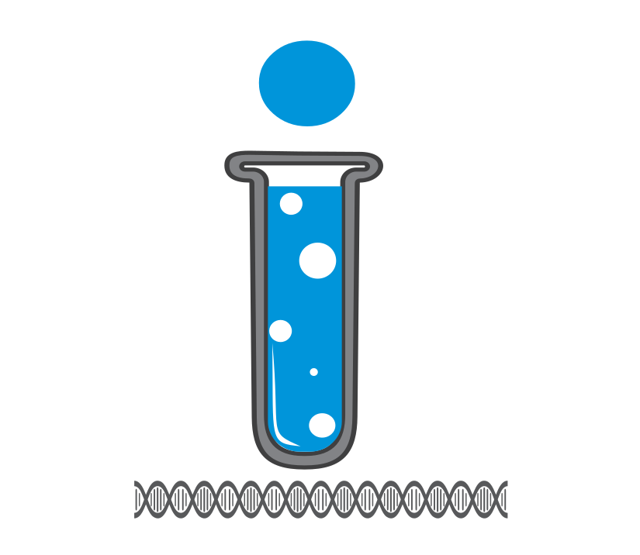
Figure 1. Figure description (caption)
The figures must be numbered sequentially, have a legend, and be included in the manuscript. All necessary explanations (abbreviations or symbols) should appear in the footnotes of the figure. Additionally, you must upload the images in a separate file that allows their subsequent layout, for the type of format and resolution, please consult the guidelines for author. If the figures are not of your authorship, without exception, you must send INNOVACIENCIA the authorization signed by the publishing house or person who holds the copyright where you grant the publication permission.

Figure 4 example: https://revistas.udes.edu.co/innovaciencia/article/view/4843/3380 or Figure 4 https://revistas.udes.edu.co/innovaciencia/article/view/4951/3384

Table 1. Table description (caption)

xxxxxxx | xxxxxxx | XXXX |  |  | XXX
xxxxxxx | xxxxxxx | XXXXX | XXXXX | XXXXX | XXXXX | XXXX | XXXXX
Note: All the necessary explanations should appear for clarity to the reader (abbreviations, symbols, statistical test used for the calculation of the p-value, etc.,).
Tables should be numbered sequentially as follows (Table 1, Table 2, etc.), have a legend, and be included in the manuscript in editable or compatible Word format. In percentage data, for decimals (present two decimal places and the "n" in parentheses, e.g., 10.27% (14)). When references are cited in tables, they should follow the order in which they were used in the text.
Table 1, example: https://revistas.udes.edu.co/innovaciencia/article/view/4951/3384
In case your manuscript has original data in extensive tables with relevant information that cannot be incorporated as a Word file, submit them as a supplementary file in Excel format. These files must be properly numbered and have an associated legend in the text. Table´s ID should appear as follows: Table S1, Table S2, etc. If the tables are not of your authorship without exception, you must send to INNOVACIENCIA the authorization signed by the publishing house or person who holds the copyright where you grant the publication permission.

DISCUSSION
This section should provide an interpretation of the previously described results. Emphasize new and important aspects of your findings and compare them with other relevant studies. This section serves as a platform to reflect on the new knowledge generated, its connection to existing knowledge, and potential implications.
Where appropriate, discuss the influence or association of variables and acknowledge any limitations of the data. Avoid simply repeating information presented elsewhere in the manuscript, such as the Introduction or Results sections. (Garamond 12pt, line spacing 1.5). xxxxxxxxx xxxxxxxxxxxxxx xxxxxxxxxxxx xxxxxxxxxxx xxxxxxxxxxxxxx xxxxxxxxxxxxxx xxxxxxxxxxx xxxxxxxxxx xxxxxxxxxxx xxxxxxxxxxxx xxxxxxxxxx xxxxxxxxxxx xxxxxxxxxx xxxxxxxxxxxx xxxxxxxxxxxxxxxx xxxxxxxxxxxx xxxxxxxxxxx xxxxxxxxxxx xxxxxxxxxx xxxxxxxxxx xxxxxxxxxxxxx xxxxxxxxxxxxxx xxxxxxxxxxxxxx xxxxxxxxxxxx. xxxxxxxxxxxxxx xxxxxxxxxxxx xxxxxxxxxxx xxxxxxxxxxxxxx xxxxxxxxxxxxxx xxxxxxxxxxx xxxxxxxxxx xxxxxxxxxxx xxxxxxxxxxxx xxxxxxxxxx xxxxxxxxxxx xxxxxxxxxx xxxxxxxxxxxx xxxxxxxxxxxxxxxx xxxxxxxxxxxx xxxxxxxxxxx xxxxxxxxxxx xxxxxxxxxx xxxxxxxxxx xxxxxxxxxxxxx xxxxxxxxxxxxxx xxxxxxxxxxxxxx xxxxxxxxxxxx. xxxxxxxxxxxxxx xxxxxxxxxxxx xxxxxxxxxxx xxxxxxxxxxxxxx xxxxxxxxxxxxxx xxxxxxxxxxx xxxxxxxxxx xxxxxxxxxxx xxxxxxxxxxxx xxxxxxxxxx

CONCLUSIONS
This section expresses the opinions and concepts, based on the results, that they arrive at after the discussion. Declare new hypotheses when justified but make it clear that they are hypotheses (Garamond 12pt, line spacing 1.5) xxxxxxxxx xxxxxxxxxxxxxx xxxxxxxxxxxx xxxxxxxxxxx xxxxxxxxxxxxxx xxxxxxxxxxxxxx xxxxxxxxxxx xxxxxxxxxx xxxxxxxxxxx xxxxxxxxxxxx xxxxxxxxxx xxxxxxxxxxx xxxxxxxxxx xxxxxxxxxxxx xxxxxxxxxxxxxxxx xxxxxxxxxxxx xxxxxxxxxxx xxxxxxxxxxx xxxxxxxxxx.

ACKNOWLEDGMENTS
xxxxxxxxx xxxx xxxxxxxxxxx xxxxxx xxxxxxxxxxxxxxxxx xxxxxxxx xxxxxxx

ETHICAL CONSIDERATIONS
In research involving humans, animals, plants, or microorganisms, an Ethical Considerations section must be included specifying the standards with which the study complies, the name of the Ethics Committee that approved the research, and the registration number or record issued by the Committee. If applicable to the study, permits for the collection of microorganisms, plants, and animals should also be mentioned. (Use: Garamond 12 pt font, 1.5 line spacing)

FUNDING
xxxxxxx xxxxxx xxx

DECLARATION OF COMPETING INTEREST
xxxxxxx xxxxxx xxx

REFERENCES

Please review this section carefully and follow the instructions given for authors to construct references: https://revistas.udes.edu.co/innovaciencia/Instructionsauthors

Institutional Affiliation, e-mail, ORCID
Institutional Affiliation, e-mail, ORCID
Institutional Affiliation, e-mail, ORCID * Corresponding Author

